Organizing Armageddon: What We Learned From the Haiti Earthquake
- By Vince Beiser
- April 19, 2010 |
- 12:00 pm |
- Wired May 2010

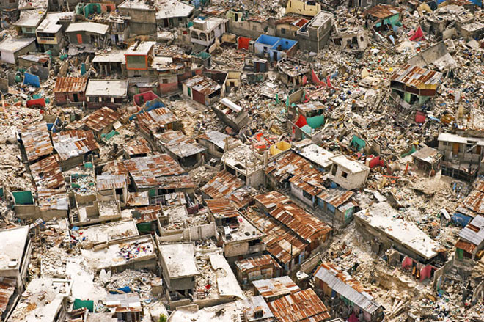
Armageddon from above.
Photo: Cameron Davidson/Corbis
Haiti Rewired
Join an ongoing conversation about technology, infrastructure and the future of Haiti.
Pauli Immonen is quick-marching the length of the tarmac at Port-au-Prince’s crippled airport, looking for a missing 737. It’s not as if he can just check the arrivals board — the 7.0 earthquake that rocked the Haitian capital eight days ago has left the main terminal a flooded, deserted husk. The floors are littered with broken ceiling tiles, and inch-wide cracks snake along the walls. Outside, Immonen skirts a blacktop crowded with military transports and chartered jets; the flock of small planes that usually roosts here has been forced onto an adjacent patch of grass. The noise is as oppressive as the afternoon heat — deep belly rumbles from taxiing aircraft, the basso whup-whupping of helicopter blades, the grumbling and reverse-signal beeps of forklifts and buses.
Spotting a promising-looking Boeing, the lean, 42-year-old Finn hurries over to the two Nordic types at the foot of the stairs leading up to the plane and introduces himself. Sure enough, it’s the flight from Iceland he is expecting — a civilian charter, complete with blond flight attendants, here to drop off aid and a relief team and to pick up a search-and-rescue crew. Immonen bounds up the steps and talks his way through more people until he finds someone from the Icelandic Ministry for Foreign Affairs. The official asks Immonen if he’d care to step outside and check their cargo. “Yes,” Immonen replies crisply, in flawless but accented English. “But first let me get a drink from one of your lovely ladies.”
A flight attendant looks up with a professional smile and opens a snack-laden drawer in the galley. She extracts a couple of Fantas. Immonen gets a look at the stock and courteously but unsmilingly requests a can of Pringles as well. He’s worked enough disasters to know that you have to grab high-calorie snacks when you can. She hands one over, and Immonen leads the official off the plane.
Immonen hit the ground in Port-au-Prince less than 72 hours after the quake, when the streets were still strewn with corpses. He arrived from Helsinki with little more than a mosquito net, a sleeping bag, a laptop, and a sat phone. When he snatches a few hours of sleep, it’s in a tent pitched 100 yards from the airport runway. A member of one of the Red Cross’ Emergency Response Units, Immonen has been a first responder in crisis zones from Darfur to Afghanistan to Pakistan.
His job is to wrangle airplanes, making sure that the people and materiel on every Red Cross relief flight get to where they’re supposed to be. He’s been fascinated by aircraft since he was a kid, hanging around the local airport taking snapshots of planes. He parlayed his Finnish Air Force training into a stint with the United Nations peacekeeping force in Lebanon and has been doing humanitarian work since 1995. The military has left a mark on his personal style: Whereas most of his colleagues are shaggy-faced and grubby by this stage of the operation, Immonen shaves daily and always keeps his Red Cross T-shirt tucked neatly into his jeans. “You have three jobs in the field,” he says, “taking care of the planes, paperwork, and yourself. But the first couple of days, you only do planes.”
Shot a week after the Jan. 12 earthquake in Haiti, these stunning images of the devastation and recovery effort were captured by Q. Sakamaki. Wired reporter Vince Beiser narrates.
Chips in hand, Immonen sets out across the tarmac again, all the while exchanging rapid-fire radio calls with the Red Cross base camp a couple of miles away in Port-au-Prince and trading text messages with its logistics hub in Panama. A second flight, this one from Germany, has also arrived. Supposedly. Earlier today, Panama told Immonen that an incoming Red Cross plane had landed, but someone forgot to mention it had been diverted to the neighboring Dominican Republic.
He finds the German flight, though, and gets to work lining up trucks to take its cargo into town. He shakes hands with at least 20 people in as many minutes, extracting and dispensing required information, bluntly cutting off conversations when they wander off-topic. “I’m not polite,” Immonen tells me between impromptu meetings. “Sometimes you have to be military. If you make one small mistake, the shipment goes to the wrong place, and then it might as well be lost.”
Getting the right aid to the right place is the whole reason Immonen — and hundreds of people like him — are here. The world responded to the Haiti earthquake with one of the biggest international aid efforts ever mounted, sending thousands of tons of food, water, and medicine pouring in from every corner of the globe to a tiny island that had little infrastructure even before the ground started convulsing. Physically moving those supplies into the country, let alone getting them into the hands of the millions who needed help, posed a logistical problem of epic proportions. The capital’s port was wrecked, its airport badly damaged, and its roads choked with rubble and bodies. More than 200,000 people were dead; at least 2 million were homeless.
For people like Immonen, it was the latest in a lifetime of urgent reasons to fly halfway around the world. But the disaster was also a laboratory, a rare opportunity to test methods and technologies that define “mission critical.” For the world’s emergency relief agencies, Haiti is the latest on-the-job experiment in the developing field of humanitarian logistics.
Despite the massive scale of their operations, only in recent years have the people who deliver disaster aid begun to benefit from the kind of data-driven decisionmaking and rigorous academic study that their commercial and military counterparts rely on. In the past decade, the responses to major disasters have been analyzed in hundreds of case studies and pored over by experts, their conclusions field-tested in subsequent crises where yet more data is collected. Learning the right lessons could not be more important: The stakes are literally life and death.
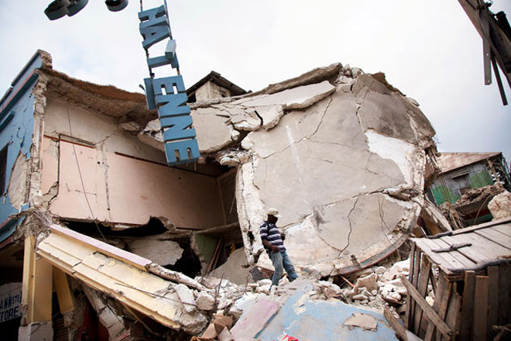
After the earthquake leveled Port-au-Prince, inhabitants scavenged what supplies they could from the rubble.
Photo: Q. Sakamaki
Today, more people than ever are vulnerable to natural disasters. Population growth and environmental degradation mean that the average number of people requiring help each year after storms, droughts, epidemics, and other natural catastrophes has skyrocketed in recent decades. More than a billion people now live within 62 miles of an ocean; an estimated 10 million are hit by floods every year. Thanks to global climate change, that number is expected to quintuple by 2080.
Earthquakes are an even more lethal threat, particularly in poor countries. Port-au-Prince and its environs collapsed because of the shoddy construction that is the norm in developing-world megalopolises from Mexico City to Chengdu. Haiti’s 7.0 temblor ranks among the deadliest ever recorded, on par with the quake-induced tsunami that struck Indian Ocean shorelines in 2004. Indeed, in the past 40 years, earthquakes and the tsunamis they spawn have killed more people than any other kind of natural disaster.
Aid agencies have ramped up apace. The number of emergency humanitarian workers worldwide has grown at a rate of 6 percent for the past 10 years, reaching a total of more than 210,000. In 2008, government and private donors gave $6.6 billion to international response efforts, nearly triple the 2000 total. It seems to be helping: Since 1975, the number of people actually killed in disasters annually has dropped by almost half.
Still, there’s no question that the global emergency relief system has significant shortcomings. Governed for decades more by rules of thumb than research, it’s still more art than science. Humanitarian supply chains are generally less efficient and the people running them less well trained than their commercial and military counterparts. They also suffer from a chronic lack of coordination. Dozens or even hundreds of groups swarm into disaster zones, tripping over one another, duplicating efforts, and competing for trucks, fuel, and food.
What We’ve Learned
Researchers have been studying better ways of responding to disasters for two decades. Here are a few lessons taken from a series of unfortunate events. — Rachel Swaby
1988
December 7
Armenian Earthquake
Lesson: Employ local. Armenia was part of the Soviet Union, but Moscow prohibited residents from working on rebuilding, causing political tension. Four years later, only 30 percent of necessary structures were finished.
1995
January 17
Kobe Earthquake
Lesson: Communicate better, more often, and more completely. A lack of timely and accurate information made it difficult for families to get services they needed. For example, shelter locations were not well publicized, which delayed relief.
1999
August 17
Turkish Earthquake
Lesson: Rebuild stronger. After quakes destroyed unsafe structures, rebuilding started quickly and without regulatory oversight or regard for the individual needs of each city — resulting in yet more vulnerable construction.
2003
December 26
Iranian Earthquake
Lesson: Restore law and order quickly. Refugees from the countryside flooded the city in search of aid, but there was no system to support them. Several days of looting hindered distribution of supplies and threatened the overall recovery effort.
2004
December 26
Asian Tsunami
Lesson: Basic provisions need to be regionally appropriate. Workers distributed non-halal food and built shelters inside Buddhist temples, so Muslims couldn’t eat the food or use the shelters. Also, some donated goods weren’t suitable for the climate.
2005
August 29
Hurricane Katrina
Lesson: Aid has to be delivered quickly but also sensitively, especially when it comes to services like finding loved ones or burying the dead. A fifth of aid recipients in Louisiana said assistance came too late and was delivered in an uncaring manner.
2005
October 8
Pakistani Earthquake
Lesson: Medical care needs to be culturally appropriate. Few female doctors were deployed, and local religious beliefs restrict physical contact between men and women. This severely limited the care available.
2006
May 27
Java Earthquake
Lesson: Prepare. Areas where households had received some disaster training were able to deliver aid to others before official help arrived. People in those regions surveyed after the quake indicated that they appreciated such assistance.

Lynn Fritz thinks he can help. He built his family’s customs brokerage company into a global logistics outfit with branches in 123 countries. As a result, Fritz’s employees were regularly the victims of disasters themselves. “Every year, there would be an earthquake or a mud slide or something that would stop us from working somewhere,” Fritz says. “We got good at getting our people back to work quickly. But I found that, generally speaking, none of my employees were happy with the help they and their families got from aid organizations.”
In 2001, after selling the business to UPS for a reported $450 million, he founded the Fritz Institute, a San Francisco-based consultancy intended to take his company’s experience moving goods and apply it to the unruly world of emergency aid. It has since become a major catalyst in a growing movement to improve the performance of relief agencies. Among other things, Fritz launched an annual international conference on humanitarian logistics that brought many of the key practitioners together for the first time and helped spur the growth of a handful of university programs aimed at bringing sophisticated research to bear on this unique field. “Humanitarian logistics in 2001 was very similar to where commercial logistics were when I started out — very lowbrow, low-status, low-paid,” he says. “Now it’s going through the same evolution, from an obscure back-office thing to ‘Christ, this is important!’”
Things came to a head after the 2004 tsunami that killed 225,000 people in South Asia. With some 400 groups piling onto what was then the biggest international aid effort ever seen, airports were overwhelmed and supply routes bottlenecked. “There was literally food sitting in depots that no one knew was there,” Fritz says. “There were an enormous number of avoidable problems.” The scale of the tsunami’s carnage — and its attendant media coverage — brought unprecedented attention to the flaws in the global relief system, sparking the humanitarian world’s most sweeping self-analysis since the Rwandan genocide.
Colin Chaperon spent his first night in Port-au-Prince in the grass outside a Red Cross office. Even before the earthquake, the country was a shambles, battered by decades of crippling international debt, corrupt leaders, and frequent hurricanes. Lots of international aid groups already had semipermanent presences there — which meant they got hit as hard by the quake as everyone else. About 100 United Nations workers, including the mission chief, were killed. All of the staff at the Haitian Red Cross survived; its headquarters did not.
(A quick word about the Red Cross: It’s actually a loosely linked constellation of “national societies” around the globe — the American Red Cross, the Egyptian Red Crescent, and so on. Then there’s the Geneva-based International Federation of Red Cross and Red Crescent Societies, or IFRC, which coordinates the work of the national societies in disaster relief operations. Yet another Red Cross agency does the same thing in war zones.)
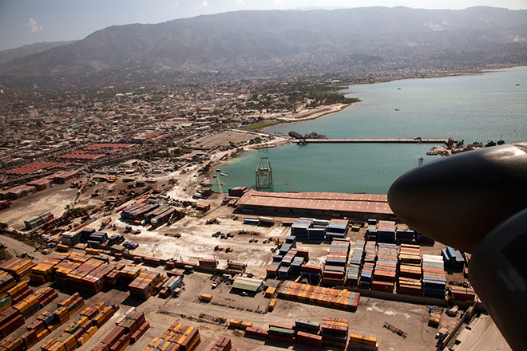
◄ Back
Next ►
Picture 1 of 13
Not all of photographer Q. Sakamaki’s stunning shots could be included in the print version of this story. Click through this gallery to view some of those images. Above: The main port of Port-au-Prince is seen from a military helicopter.
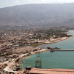 | 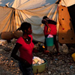 | 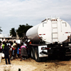 | 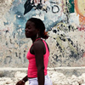 |  | 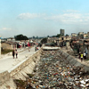 | 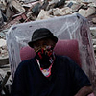 | 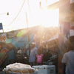 |  | 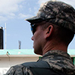 | 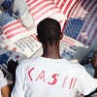 | 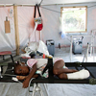 | 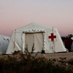

Chaperon, a 35-year-old American who grew up in Zimbabwe, came to Haiti as part of an IFRC assessment team. All the big aid outfits — UN agencies, Oxfam, et cetera — field similar teams when disasters hit. They’re composed of hearty cowboys who are the first to hit the ground, alongside the search-and-rescue squads and emergency medical crews, tasked with figuring out everything from physical conditions to local customs to what food and transport are available. Telecom teams arrive just as quickly to set up phonebook-sized satellite transmitters to provide Internet access to key locales like the IFRC base camp. It’s one part of the four-part structure of aid: The assessment teams land first; then comes a steep ramping-up called deployment, followed by a leveled-off, longer period of sustainment. The end is a slow, tapering reconfiguration that, in theory, allows the local society to start functioning again.
Less than two days after the quake, Chaperon was scouting the city in a Land Cruiser, accompanied by a Haitian Red Cross volunteer. Though he has worked relief operations from Pakistan to Indonesia, Chaperon had never seen anything like what he found on his first assessment tours of Port-au-Prince. “There were bodies piled up in the streets, bodies sandwiched in the rubble, children …” he says, his voice trailing off. “You go in thinking you’re prepared, but when you actually see it in person, it’s just stunning.” It wasn’t hard to find folks who needed help. Tens of thousands of newly homeless locals huddled out of the tropical sun in shelters cobbled together out of scraps of cloth, plastic, and wood in ad hoc camps set up in parks and vacant lots all over the city. Chaperon stopped at several to eyeball the situation and talk with the locals. Clipboard in hand, he jotted down key indicators like access to water, numbers of children, availability of improvised shelter materials, and whether any other aid outfits had already been there. He snapped the occasional digital photo to augment the reports and logged the location of each camp with a GPS unit — critical in places like Haiti where there never were many street addresses to begin with. Back at base camp, his findings would be added to those of other assessment teams, along with information from media reports and other sources, in an ever-growing database. “We’re supposed to assess what the immediate needs are — do people most need food, or water, or tents?” he says. “The challenge here is that all the sites need everything.”
GPS and digital mapping tools have helped make this assessment phase even more precise. After the Yogyakarta earthquake in 2006, the World Bank, the IFRC, and the Indonesian government collected information from a range of aid organizations and overlaid it with demographic data showing the region’s poorest and most vulnerable populations to create a detailed picture of the quake’s social impact. In Afghanistan the following year, aid organization Care combined GPS data with local hand-drawn maps to generate up-to-the-minute maps of areas needing help.
In Port-au-Prince, experts with a UK-based group called MapAction were on the ground within days, combining satellite imagery with data from the UN, Google, and their own scouting to generate maps showing homeless encampments, blocked roads, and collapsed bridges. UN technicians crunched satellite data and reports from aid workers and others on the ground, generating maps and demographic profiles to figure out how many people needed help. The number they arrived at was staggering: An estimated 3,725,615 people lived in the areas hit by the quake — more than one-third of the entire country. Daunting as that number was, at least it was information. Now the world had an idea of how much aid Haiti needed, and what kind.
Like an armory for aid and comfort, the IFRC’s Panama hub — located in a former US Air Force base near the canal — stockpiles a couple of dozen four-wheel-drive vehicles, 270 cellular phones, four satellite phones, four water-treatment systems, and shelter and sanitation supplies to support 25,000 families. Almost all of that is now in Haiti, as are vehicles and other gear shipped from Dubai and the Canary Islands.
The supplies in Panama are part of an approach called prepositioning, a relatively recent improvement to disaster logistics. The chaotic response to the 2004 Asian tsunami showed that the aid organizations’ centralized systems weren’t nearly efficient enough. “Goods were being flown from China to Europe and then back to Indonesia,” says Birgitte Olsen, who became the IFRC’s chief of logistics the previous year. She enlisted researchers at a handful of European business schools to figure out a better way of doing things. “For the first time, we really gathered the statistics and information to analyze the costs of our supply chain,” Olsen says.
What they found astonished them. It could take up to two weeks to move food and supplies to where they were needed, and it cost way too much. So in 2006, the IFRC overhauled the whole thing. The organization built more logistics hubs, including depots in Dubai and Kuala Lumpur, choosing locations that were near disaster-prone areas but reasonably safe and politically stable. They also had to have good transportation and communication links, competent local staff, and simple import-export rules. A year after that, Dubai set aside a special tax-free area dubbed International Humanitarian City, where dozens of aid outfits base their African and Middle East operations. And the UN has opened several depots around the world for aid groups to use as logistics bases “Our hubs have shortened the time it takes us to set up a supply chain from 15 days to three to five days,” Olsen says. “And they’ve cut the price of helping a family from about $740 to $185.”
The very first post-quake Red Cross aid to be distributed in Haiti was prepositioned on the island itself. The IFRC keeps containers filled with supplies for a few thousand families sitting on several Caribbean islands, in anticipation of the inevitable hurricanes. When the bad times hit, the local national societies just open up the containers.
Other, more mission-specific assets came from farther away — though almost as quickly. Within days of the quake, a Norwegian Red Cross team had unfolded a completely self- sufficient clinic — two full surgical wards’ worth of tents, medicines, and sterilized equipment as well as food, beds, computers, generators, water-purification units, and lighting — in a courtyard of Port-au-Prince’s shattered main hospital. A week earlier it had been a collection of 350 aluminum boxes, weighing a total of 12 metric tons, in a warehouse outside of Oslo.
Broken cranes and cracked pavement made the port almost unusable. At the airfield, which became the base of operations, air traffic control was knocked out. The US Air Force initially used a portable radio to land planes.
Photos: Q. Sakamaki
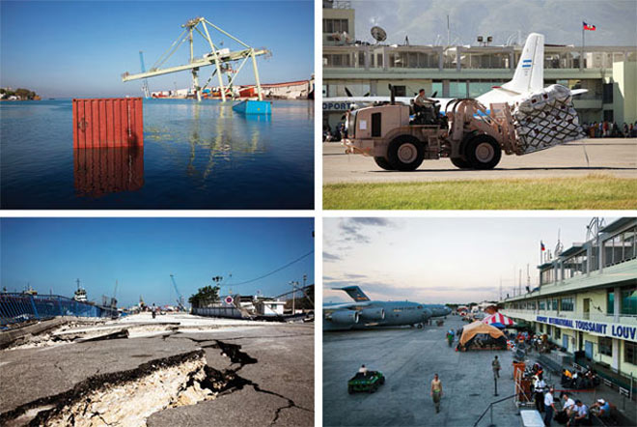
Photos: Q. Sakamaki
Governments donate huge amounts of food and other bulk items to the big aid agencies for warehousing. But not everything can be stockpiled: Food and medicines go bad, and every bunch of disaster victims has their own specific needs. Pork-based MREs don’t go over so well in Muslim countries, for instance. To fill the gaps, most organizations have standing deals with commercial suppliers and transport companies. In an emergency, they order up whatever they need at a preset price, without having to waste time seeking bids and negotiating contracts. For the Haiti operation, the Red Cross alone brought in mosquito nets from Vietnam, medical equipment from Europe, and tarps, cooking gear, and hygiene equipment from India and China. Almost all the goods are made to detailed uniform standards. Every blanket, for instance, is the same size, thickness, even color, no matter which supplier produced it. That allows the logisticians to calculate precisely the volume and weight of each order, which in turn enables them to plan what sort of transport and storage facilities will be needed.
When they have to buy stuff that isn’t covered by those standing agreements, the Red Cross requires that the items fit the standards laid out in its online catalog of emergency aid. The catalog gives detailed specs for more than 2,000 items, down to the width and length of bandages and the vitamin content of powdered milk.
Other international agencies developed a broad set of guidelines after the Rwanda genocide in 1994. Dubbed the Sphere Project, it sets baseline standards for aid. So one individual is supposed to get 7.5 to 15 liters of water (for drinking, cooking, and washing) and 2,100 calories of food per day, plus 3.5 square meters of floor space in a covered shelter. Those standards are often more goals than practical guidelines, however. In the initial heat of a crisis, deciding which supplies to send first requires some cold-blooded calculations. In the first days after the Haiti quake, the Air Force gave higher priority — and earlier landing slots — to planes carrying bottled water, food, and medical supplies, figuring that hydration and nutrition were more pressing needs than shelter in a temperate climate like Haiti’s.
In general, Sphere guidelines leave plenty of room for improvisation. Catholic Relief Services’ branch in the Dominican Republic simply hit local stores and bought up all the granola bars, canned sardines, and peanut butter it could get. Such foods are non-perishable, protein-rich, and easily portable. They also don’t require any cooking, a crucial consideration for disaster victims who likely have no stoves, fuel, or even frying pans.
Ten days after the quake, downtown Port-au-Prince is still flat-out apocalyptic. On block after block, multistory buildings lie smashed into rubble. Falling debris has crushed cars like juice boxes. The streets teem with people with nowhere else to go, many of them wearing surgical masks to ward off the stench of corpses rotting in the wreckage. Armed soldiers and stray dogs roam about as helicopters thunder overhead.
To figure out how to move aid into and around that anarchic environment, and then ensure it’s delivered to the Haitians who need it, the IFRC relies on logistics coordinator Ian Heigh. For now, his office is a metal chair pulled up to a folding table in a long, single-story warehouse. The floor is rough cement, the roof corrugated tin, and one wall just open mesh. Another dozen teams are also crammed into the building, their improvised workspaces all within a couple of feet of each other. It’s constant cacophony. Red Cross workers from around the world, as well as dozens more from the Haitian Red Cross, bustle and plan and prepare for missions here from dawn until late at night. Buzzing generators power a vast flock of sat phones, walkie-talkies, and laptops. At least the commute is easy; everyone sleeps in tents pitched in the rocky yard outside.
It’s 7 am and Heigh is doing his best to shut out the commotion and focus his team on the day’s priorities. A burly former British Army engineer, Heigh sports a couple of days’ worth of stubble, a silver hoop in each ear, and purple rings around his eyes. Today he’s preoccupied with the million niggling details that make it possible to move water, clothing, and medical supplies from point A to hundreds of point Bs. The problem is, the earthquake mangled the airport, the seaport, and the roads.
Before the quake, Toussaint L’Ouverture International Airport handled an average of 35 flights a day. The quake knocked the control tower out of commission, leaving aircraft to land in whatever order they arrived in Haitian airspace. Traffic was desperately bottlenecked, with at least 15 planes circling overhead at a time. There wasn’t enough space on the ground for them all, and too few forklifts and trucks to unload the planes once they landed.
That’s why one of the first planes that did land carried a team from the US Air Force’s Special Tactics Group. The crew sized up the situation, plunked themselves down in the grass near the runway, fired up their portable radios, and started giving orders to the circling aircraft.
Aid agencies complained that military flights got top priority, but without the USAF, nothing much would have gotten in at all. The Special Tactics Group established a reservation system for incoming aircraft and took over the job of unloading planes themselves. By the time I joined Immonen on his rounds a few days later, the airport was handling more than 100 flights a day.
But even operating at peak efficiency, no airport can take in enough cargo to feed, clothe, and house an entire city. Only cargo ships and trucks can deliver that. The quake left two small top-loader cranes at the capital’s eponymous port listing at crazy angles, and its single large gantry crane (the kind that handles containerized cargo) keeled over into the water as though it had been knocked to its knees. That meant only ships equipped with their own cranes could tie up to unload at the single working pier, which itself was so rickety it could support just one truck at a time. The US Coast Guard took charge, scraping a chunk of nearby shoreline to allow flat-bottomed cargo boats to pull right up to the beach. “It’s a lot of improvising,” lieutenant commander Mike Pierno says.
The rest of the aid must be hauled in by road. But Haiti, of course, is on an island, one it shares with the Dominican Republic, a third-world nation that looks prosperous only by comparison. The DR staggered under the huge quantities of aid and people being channeled through its airports and harbors. The few trucks the aid agencies managed to cadge to get supplies out of the DR and into Haiti were in for a grueling journey. The two-lane, convoy-congested road between the two nations’ capitals is nothing but pothole-cratered dirt for considerable stretches. The 156-mile trip can take up to 12 hours.
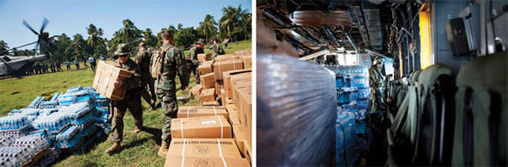
Within days of the quake, US marines were using military choppers to deliver water and rations to outlying areas.
Photo: Q. Sakamaki
At the airport, an open field near the tarmac is filled with off-loaded cargo — acres of pallets stacked high with water bottles, rice sacks, kitchen kits, diapers, toilet paper, bandages, absorbent nursing pads, and other supplies. The US Army is in charge of getting all this stuff to aid groups for dispersal. Most are close by; with habitable buildings in short supply, dozens of international organizations have set up camp next to the airport, creating a sort of humanitarian Black Rock City. Giant 20-person shelters jostle for space with clusters of pup tents, lighting rigs, satellite dishes, generators, and piles of gear and food. Shirtless Russian search-and-rescue guys sun themselves next to a group of Danish child-welfare workers, while nearby a Mexican TV crew interviews a Peruvian firefighter in blinding yellow coveralls. Next to Immonen’s tent sit a half-dozen refrigerator-sized generators. They’re meant for a US military hospital, but the grunts running the forklifts figured the red crosses painted on the boxes — an international symbol for anything medical — meant they belonged to the IFRC.
One of Heigh’s urgent tasks is finding warehouse space for incoming relief. At the moment, trucks are off-loading cargo into the other end of the building where the emergency teams are working, adding to the noise, dust, and general chaos. Worse, the space is too narrow for forklifts. The logistics team has a couple of leads on an alternate site, but the buildings need to be checked out to make sure they’re still structurally sound. Heigh also needs to find scarce vehicles and drivers, hire day laborers, and secure the aid workers’ camp fuel supply — which is currently sitting in barrels in a nearby lot protected only by a couple of unarmed security guards.
Heigh also has to keep a handle on what he has: The IFRC records tracking numbers on its goods by hand because it has yet to invest in barcode scanning equipment, and until recently, there wasn’t any specialized, networkable software to monitor goods in the humanitarian supply chain. Now Heigh has access to a customized version of Humanitarian Logistics Software, a system developed by the Fritz Institute. It’s become something of a standard for monitoring aid delivery, in no small part because it’s Web-based and the Institute gives it away royalty-free.
The truth is, no amount of preparation can survive contact with the actual conditions of a disaster. Still, Heigh draws up a plan and parcels out tasks. “When we go to the field, of course,” he tells his staff cheerily, “none of this will work, and we’ll end up doing something completely different.”
Humanitarian logistics as a discipline lives somewhere on a continuum between the ultrahigh-speed, money-is-no-object imperatives of a military campaign and the customer-focused, margin-cutting mentality of a commercial supply chain. Indeed, one of the biggest ideas to hit the humanitarian community in the past decade is the notion of surveying the recipients of aid to see what they think. That’s very commercial — treating them more like clients than victims. But trying to accommodate local sensitivities can also come at the expense of speed and efficiency — and the safety of the people delivering the aid.
That tension plays out most clearly during the actual delivery of supplies to people who need them. A crowd of hungry citizens can quickly turn into an angry mob of looters. There’s an ugly chicken/egg aspect to the whole security issue. Aid workers can’t distribute food unless there’s a certain level of safety, but lack of food makes people more desperate and the situation more dangerous. So a key question — both tactical and ethical — is, do you take guns with you?
How you answer that depends on who you are. I spend one morning inside the UN’s bustling compound near the airport, hanging out with a couple of World Food Program workers next to a truck parked at the head of a convoy. Drivers are loitering in a scrap of shade nearby, smoking and grumbling in Creole. We’re waiting, and waiting, for soldiers from the United Nations Stabilization Mission in Haiti — Minustah is the French initialism — to come escort us on a food distribution run. Phone calls are made. World Food Program officials come and go, trading rumors: We’ll be going soon. No, it’ll be another hour. There are no Minustah soldiers available. Then we hear that the Americans are sending some troops. Finally, it gets to be too late and the whole mission is scrapped.
That means those trucks filled with food will sit where they are until at least the next day. Meanwhile, just a few hundred yards away, on the other side of the compound’s steel gates, is a street teeming with hungry, thirsty Haitians. But in Haiti, the World Food Program will roll trucks only with an armed escort from Minustah or the US Army. They’re protected, but also debilitatingly dependent on their military partners.
The military itself doesn’t need anyone else’s muscle. Within days of the quake, 13,000 US troops had been dispatched to Haiti. And when they want supplies to move, they move. One afternoon, I hitch a ride on a CH-53 Super Stallion, a hulking gray beast of a Marine helicopter. It’s built for function, not comfort: Steel walls and ceiling are covered with a maze of cables, wires, and medical gear. The only adornments are a couple of Skoal stickers and a little poster of Raquel Welch in One Million Years BC taped up near the cockpit.
Following the gestured instructions of one of the four crew members — you can’t hear anything over the rotors — I strap into a spartan fold-down seat. Six tied-down pallets of water and boxes labeled human daily rations wobble on the steel deck as we rise from the airport’s crowded tarmac and soar out over the shattered city. Within minutes, we’ve left Port-au-Prince behind and are flying over vibrant green farmland dotted with little white houses. It would be picturesque if so many of the little houses weren’t collapsed.
The copter lands in an open field near the hard-hit town of Leogane. A couple of dozen waiting marines hustle forward and start moving the cargo. I jump out and see that we’re surrounded. Hundreds of Haitians stand on the sides of the roads bordering the field, staring silently at the boxes of food and flats of water bottles glittering in the sun. Facing them is a line of marines, rifles pointed down but at the ready. It’s not exactly a heartwarming encounter with the locals. But it sure is efficient.
The Red Cross, on the other hand, pursues the same objective with completely different tactics. First rule: no guns. Except in the most extreme circumstances, the Red Cross doesn’t allow its supplies or personnel to be transported or protected by any nation’s military or even UN peacekeepers. That’s a central tenet of their philosophy, one of the ways the agency maintains its prized image as a neutral party no matter where it’s working.
In a place as chaotic and volatile as Port-au-Prince, though, going unarmed obliges one to tread very carefully. Teams make contact with community leaders, spreading the word that the Red Cross is coming. Then they distribute tickets, giving priority to homeless families, especially those headed by single women or that include elderly or disabled members. To avoid inciting a riot, they tell people that the tickets are part of a survey. “If word gets out you’ll be distributing aid, 5,000 people will show up,” explains Xavier Genot, a scruffy Frenchman who is helping spearhead aid distribution. Like many of the Red Cross folks here, he’s not a full-time employee but a volunteer who is called on when there’s a major disaster. In between catastrophes, he’s an architect and video artist working the French techno/rave scene.
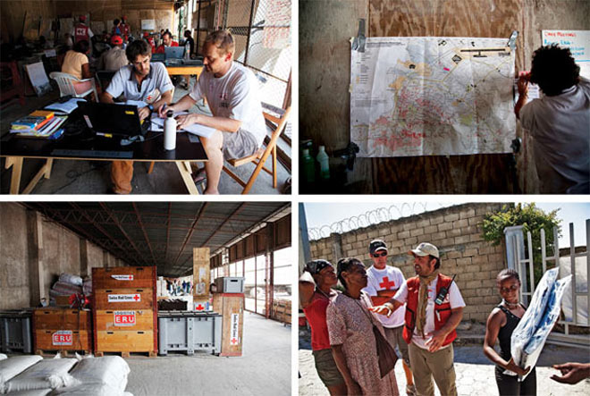
The staff of the International Red Cross/Red Crescent coordinated aid from a makeshift center that doubled as a storage depot. After key locations were pinpointed, staff distributed shelter kits in the field.
Photo: Q. Sakamaki
I join Genot on what is only the IFRC’s second aid distribution run, more than a week after the quake. Our convoy, Land Cruisers and a pair of weathered white trucks, rolls out of base camp carrying blankets, soap, and cooking supplies. It’s the start of a grindingly slow journey. Port-au-Prince’s streets were battered and potholed even before the quake; now they’re also choked with rubble, downed power lines, and people terrified to stay indoors.
Creeping up one particularly steep and narrow street, we find our way blocked by a cluster of rebar sticking out of a collapsed cement pillar. With some bystanders, we use chunks of broken cinder block to hammer the steel rods out of the way. Even Genot, a veteran of many disasters, puffs out his cheeks at the difficulty of simply moving.
Finally, we arrive in front of a two-story Haitian Red Cross field office with a massive crack down one corner. Homeless camps sprawl away on either side. Local volunteers start organizing the ticket holders into a line in the middle of the street while Genot directs the two trucks to park side by side at the end of a cul-de-sac. It’s improvised crowd control. The aid recipients will be directed up one side of the vehicles to have their tickets checked, and then back down the other side to receive their packages.
Things start off orderly enough. But word spreads quickly that the Red Cross is handing stuff out, and the street fills with people. The young aid workers link hands to form a human chain around the people in line in an effort to keep the ticketless newcomers from cutting in. But the new arrivals go around or shove past them, and the line soon triples in size. A local volunteer with a bullhorn pleads with the crowd, saying the Red Cross can help only if they cooperate, so those without tickets must get out of line, please.
No one does. Tempers are flaring. There’s pushing and shoving. A muscular man starts yelling at one of the ticket checkers, their faces only inches apart. One of the IFRC staffers quietly tells me that if the crowd swarms the truck, we are to just get out of the way.
But Genot’s team keeps things moving while the local volunteers talk down the most aggressive loudmouths. It’s tense and a bit unruly, but after an hour or so the aid has all been handed out. The crowd disperses, unhappily but without incident. Mission accomplished. But it took six hours and dozens of people to distribute aid to just 110 families.
The most persistent systemic problem with big international aid efforts, one highlighted in virtually every major study, is that no one is in charge. In a major catastrophe, thousands of high-minded, highly motivated folks pour in from all over the world. Each big agency has its own style and priorities, and each sets up its own supply chain of planes, ships, and trucks. They compete with one another for resources, duplicate one another’s efforts, and generally get in one another’s way. It’s as though 200 different police forces from New York to Podunk, plus the French Foreign Legion, the Colorado Bowhunters Association, and a squad of ninjas all launched their own attacks on the Taliban at the same time.
The result is wasted effort at best and total chaos at worst. After the 2004 tsunami, bottled water continued to arrive in Sri Lanka long after local water services were restored, clogging up supply routes. And presumably well-intentioned but clueless donors sent baffled residents of the tropical island winter jackets, stiletto-heeled shoes, women’s thong underwear, and Viagra.
That disorderly response galvanized the humanitarian world into making a number of reforms. The United Nations attempted to impose coordination via what’s known as the cluster system. Ideally, in every major disaster a designated lead organization convenes regular meetings to promote sharing information and resources. The system made its debut after the 2005 Pakistan earthquake, to mixed reviews. Getting dozens of agencies with different goals and methods to cooperate is tough in the best of times, much less in the middle of a catastrophe.
And many smaller organizations just don’t bother to take part in these interagency coordination efforts at all. “These people want to react quickly,” says Edgar Blanco, who coheads a research project on humanitarian logistics at MIT. “They don’t want to go to extra meetings and fill out forms.”
That’s been a particularly acute problem in Haiti, where — partly because of proximity to the US — over 900 organizations have rushed in to help. Few have dealt with a large-scale disaster, and they aren’t cooperating with other groups. Many people told me the cluster system is helping with coordination, but in a confidential email published online by Foreign Policy in February, John Holmes, undersecretary general for the UN’s humanitarian relief operations, complained that in Haiti “very little progress has been made in this critical area.”
Not only is no one in charge, but there are no mutually agreed-on measure of success. Blanco has tried to address this issue, evaluating humanitarian supply chains using metrics like response time, inventory rotation, and disparity between budgeted and actual outlays. His conclusion: “Their performance is very low compared to businesses like Wal-Mart.”
One reason is that aid workers have far less information about the “consumers” they’re targeting and operate in far less predictable “markets.” Displaced people in urban camps may have fled to the countryside by the time aid trucks arrive. A change in weather can mean that suddenly more water and fewer tarps are needed. “Commercial operations have detailed point-of-sale data so they know what to stock,” says Jarrod Goentzel, Blanco’s codirector at MIT. “In humanitarian operations fields, you never know exactly what the demand is, or where.”
Moreover, top aid officials often come from backgrounds in things like nutrition or sanitation rather than logistics. Even the dedicated logisticians tend to get less training. “Training and improving systems is considered overhead,” Blanco says. “Donors want to see their money going to save lives, not overhead — even though that investment provides huge returns.”
After the Asian tsunami, the Fritz Institute conducted one of the first-ever surveys of aid recipients. Only 60 percent of families surveyed in India and Sri Lanka said they had received timely aid and were treated with dignity in the 60 days after the tidal wave hit. Almost everyone reported getting water within the first couple of days, but just 58 percent of Sri Lankans reported receiving shelter in a timely manner. In general, post-disaster studies tend to measure “throughput indicators” like how much food was distributed, or how much shelter got provided, instead of “output or outcome metrics” like lives saved or suffering alleviated.
Two weeks after the quake, the international relief effort — slowly, painfully — is getting into gear. The IFRC has found a couple of proper warehouses. The pace of aid distribution has picked up considerably. The Air Force has set up a mobile air traffic control tower at the airport. The port is up to 30 percent of its capacity. Streets are being cleared. I even see crews using shovels to load garbage trucks with some of the rotting refuse that is heaped everywhere.
Nonetheless, Port-au-Prince is still a full-throttle emergency. Hundreds of thousands of people are injured, more than a million have no shelter, and the rainy season is looming. Disease is a major risk. These latter phases of aid, sustainment and recovery, often prove to be the trickiest. Flooding an area with free food can put local farmers and grocers out of business. Tents will keep people dry, but the resources spent acquiring them take away from rounding up materials and tools to create more durable shelters. It will take many months — more likely years — and billions of dollars before the city is anywhere close to recovered.
I spend my last night in Pauli Immonen’s tent near the airport runway, the better to catch a UN flight back to Santo Domingo the next day. To my astonished delight, Immonen whips up a fondue out of powdered cheese and milk on his recently acquired camp stove. We have a pleasant meal under the stars, watching the planes take off.
Eventually, I crawl under my mosquito net to sleep. Not Immonen. He’s got two more planes coming in between now and dawn.

